


Using the Leadership & Management Framework

Reflecive Log: Supporting your leadership journey

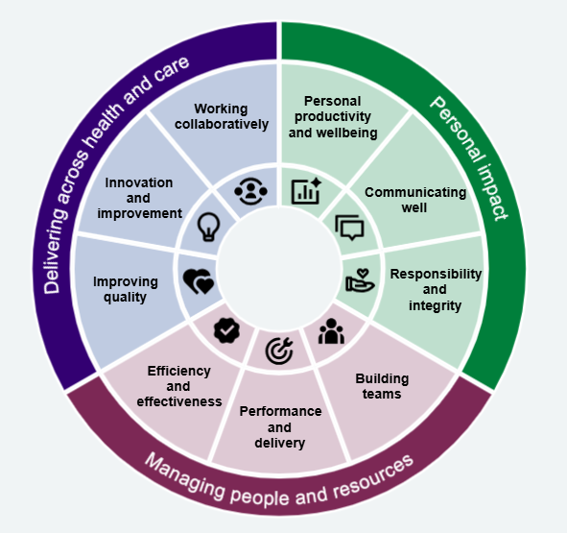

Welcome to the Leadership and Management Framework
The Leadership and Management Framework (LMF) has been developed to support managers and leaders at all levels, across all roles, working in NHS organisations.
This Reflective Log is a tool to support your personal and professional development. It is designed to complement the processes already in place within your organisation, such as appraisal and talent management. It does not replace these processes but can be used alongside them. We encourage you to share your Reflective Log with your line manager or appraiser.

Purpose of the Reflective Log
The Reflective Log is intended to help you:
- have open and constructive conversations about your Leadership and Management development, including your self-assessment report
- build a shared understanding with your line manager or appraiser of the development you have completed, the impact of your learning, and your future development needs
- plan a structured and meaningful learning journey
It may also support revalidation where this applies to your role. However, it is not designed to replace any formal revalidation requirements.

What to do next
Descriptions of each Stage and the Standards are available on the LMF microsite. To get started, you should:
- Identify your Leadership and Management Stage
- Complete the self-assessment tool
There are four Stages:
- Stage 1 – new and first-line managers and leaders
- Stage 2 – mid-level managers and leaders
- Stage 3 – senior managers and leaders
- Stage 4 – executive managers and leaders
Agenda for Change (AfC) banding is not included within the Stage descriptors, as this can vary between organisations and is not used in all settings. For this reason, NEYLA cannot provide specific guidance on selecting your Stage. Your line manager is the best placed person to explore this with.
Once you have completed the self-assessment, your report will be available directly to you. You can use the Reflective Log to prepare for discussion of your results during your next one-to-one meeting and/or appraisal.
When should I revisit the assessment?
The framework is not intended to be used as a one-off exercise, and revisiting this will help make the framework to be integral to your ongoing development. Regular reflection helps you track your growth and adapt your development plans.
You can repeat the self-assessment:
- annually as part of your development review
- after completing any development activity
- when preparing for a new role or moving to a higher level after any significant changes in your responsibilities, like taking on a new project

Important information
- This Reflective Log does not replace appraisal, talent management, or revalidation processes required for your role or professional registration.
- Reviewing your self-assessment will help you identify your strengths and areas for development, supporting your ongoing growth.

Further support
Details of current learning and development opportunities are available on the NEYLA website.
If you have any questions about a workshop or programme, please contact the NEYLA team at: cdda-tr.NELAcademy@nhs.net

The Wheel

This Reflective Log is designed to help you identify workshops and programmes that best meet your development needs.
Opportunities offered through NEYLA are aligned to leadership Stages and are clearly identified on the website. Each offer has been mapped against the Wheel to help you understand the areas of development it supports.
Where a workshop or programme does not cover all areas of the Wheel, this will be shown visually by sections of the Wheel being greyed out (see example below).
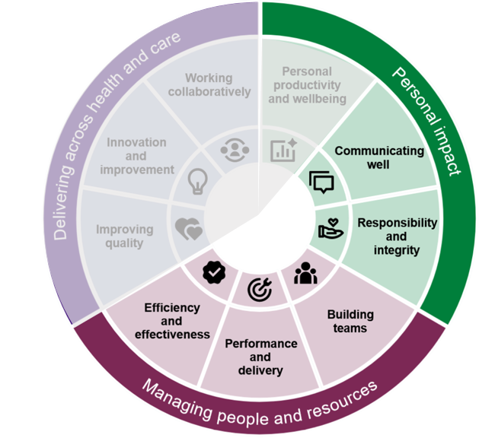

Your leadership journey
Once you have completed your self-assessment and discussed the results with your line manager or appraiser, you can begin your development journey. Ther are some prompt questions to help get this started.
This Reflective Log is self-managed. You can use it to record the learning and development activities you access and to reflect on your progress over time.
Please use the table below to keep a record of the sessions and programmes you attend.

Your name

Preferred name and pronouns

Job title
Appraisal and/or revalidation date(s)
Most challenging aspect of current role?

Proudest moment in current role?
Proudest moment in a previous role?

What is my priority area for development?

Leadership Stage  (this should be agreed in partnership with your line manager or appraiser) |  |  |  |  | STAGE 1: new and first-line managers and leaders
 |  |  |  |  | STAGE 2: mid-level managers and leaders
 |  |  |  |  | STAGE 3: senior managers and leaders
 |  |  |  |  | STAGE 4: executive managers and leaders
DATE(S) ATTENDED | WORKSHOP/PROGRAMME TITLE | WHEEL SEGMENT |  |  | REFLECTIONS & LEARNING POINTS
 |  | PERSONAL IMPACT | PEOPLE & RESOURCES | DELIVERING ACROSS H&C
 |  | PERSONAL IMPACT | PEOPLE & RESOURCES | DELIVERING ACROSS H&C
 |  | PERSONAL IMPACT | PEOPLE & RESOURCES | DELIVERING ACROSS H&C
 |  | PERSONAL IMPACT | PEOPLE & RESOURCES | DELIVERING ACROSS H&C
 |  | PERSONAL IMPACT | PEOPLE & RESOURCES | DELIVERING ACROSS H&C
 |  | PERSONAL IMPACT | PEOPLE & RESOURCES | DELIVERING ACROSS H&C
 |  | PERSONAL IMPACT | PEOPLE & RESOURCES | DELIVERING ACROSS H&C

